Jordan Schalter

A.Toma IT417

Assignment 1

04/12/2023

Q20

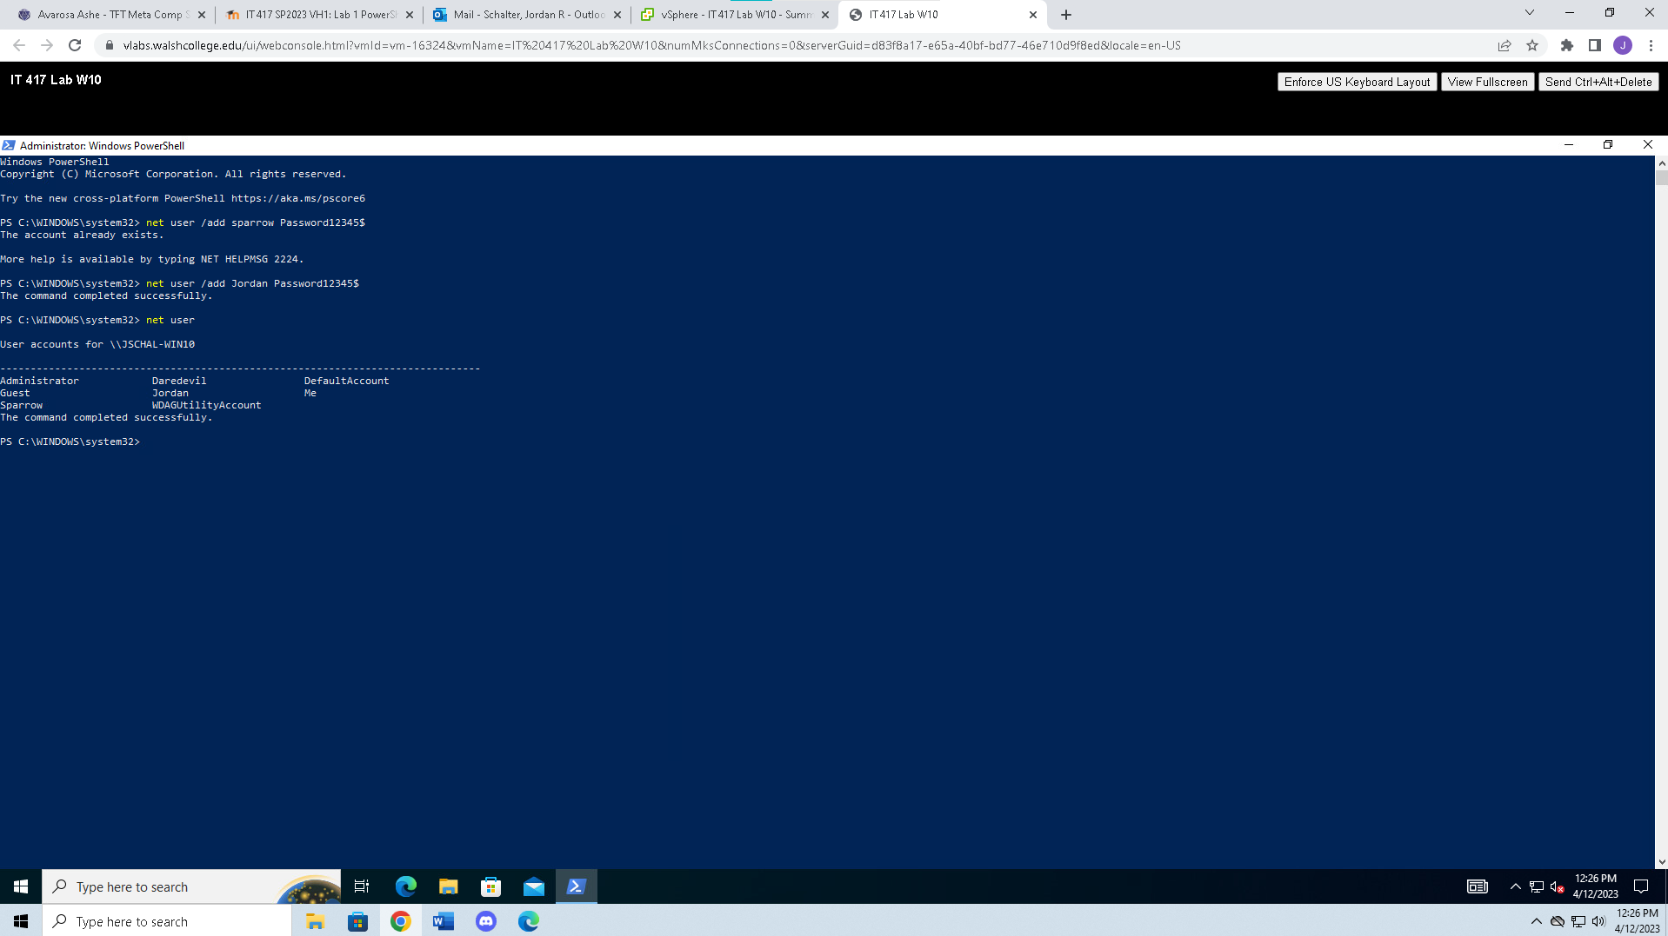

Q22

Q23

Q27

Q31

Q37

Q45

Q53

54. Answer the following questions:

d. What does the recurse (recursive) function do?

The subject of the command is the specified directory and its contents, and the Recurse parameter instructs Windows PowerShell to search for objects recursively.

e. Why would this be helpful?

When interacting with hierarchical relationships, recursive functions perform best. With the help of these functions, you can write code once and have it remain unchanged regardless of how the environment changes in the future. I assume the same will go when using PowerShell - as the recurse command allows you to see more specifically what you are looking for verses scrolling forever or trying to navigate to a specific document or file.

Q56

Q59

